**Interfacial-Redox-Induced Tuning of Superconductivity in YBa2Cu3O7-δ**

Peyton Murray1, Dustin Gilbert2, Alexander J. Grutter2, Brian J. Kirby2, Zachary E. Brubaker1,3, Rajesh V. Chopdekar4,5, Valentin Taufour1, Rena Zieve1, Jason R. Jeffries3, Elke Arenholz5, Yayoi Takamura4, Julie Borchers2, Kai Liu1,6

*1Physics Department, University of California, Davis, CA 95616*

*2NIST Center for Neutron Research, National Institute of Standards and Technology, Gaithersburg, MD 20899*

*3Lawerence Livermore National Laboratory, Livermore, CA 94550*

*4Department of Materials Science and Engineering, University of California, Davis, CA 95616*

*5Advanced Light Source, Lawrence Berkeley National Laboratory, Berkeley, CA 94720*

*6Physics Department, Georgetown University, Washington, DC 20057*

Many of the properties of the high- $T_{c}$ copper oxide superconductors are strongly influenced by charge doping1,2. The ability to control the doping level in these materials is therefore important not only for the development of experimental platforms that enable studies of correlated electron physics, but for multifunctional device applications as well. While traditionally3–6 the doping level is fixed during synthesis via chemical substitution or post-growth annealing, recently several techniques have demonstrated approaches which allow for on-demand control. By leveraging electrolytic double layer techniques, gating experiments7,8 on RBa2Cu3O7-δ (R=Y, Nd) thin films have achieved control over the Cu-site doping level, which determines the dominant electronic order, by introducing oxygen vacancies into the film under electric fields. In these materials, O2- ions can migrate under the influence of an externally applied electric field to eventually escape through the film surface, resulting in the formation of oxygen vacancies. To maintain charge neutrality electrons are returned to the Cu ions within the film, resulting in a reduction in Cu valence and reducing the hole concentration of the oxide. Signatures of the effects on the electronic order in these materials are profound, and point to the effectiveness of oxygen migration and vacancy formation in manipulating the properties of the cuprate superconductors. Recently, we demonstrated9–11 a different approach for solid-state manipulation of oxygen distributions in oxide thin films through the deposition of Gd capping layers. At room temperature Gd can react with an adjacent oxide to draw oxygen out of the neighboring film, with the level of oxygen depletion controlled by the thickness of the Gd cap. YBa2Cu3O7-δ (YBCO) is a prototypical example of the high- $T_{c}$ cuprates, with crystal structure and electronic ordering sensitive to oxygen stoichiometry. Combined with its high ionic conductivity12,13, these properties make it an ideal candidate material to explore with this method.

In this study Gd capping layers of varying thicknesses are deposited on YBa2Cu3O7-δ thin films, dramatically altering the oxygen distribution of the underlying film without any annealing. As the Gd layer thickness ($t_{Gd}$) is increased the YBCO layer becomes progressively more oxygen deficient, demonstrating how appropriate tuning of $t_{Gd}$ can precisely control the remaining oxygen content of the underlayer. Gd-capping significantly disrupts the crystallinity of the YBCO films, and a reduction in $T_{c}$ and broadening in the superconducting transition is observed with increasing $t_{Gd}$. Superconductivity is completely extinguished for the sample with thickest capping layer – a corresponding change in hole doping level from optimal doping in the as-grown film to less than 0.05 holes/Cu. X-ray absorption spectra indicate a reduction of Cu valence state consistent with the removal of oxygen from the YBCO film, particularly from within the CuO chains. Since superconductivity in YBCO relies on charge transfer from the CuO chains to the CuO2 planes, disruption of the chains is likely the root cause of the disappearance of superconductivity.

100 nm thick YBa2Cu3O7-δ films grown on (001) SrTiO3 (STO) substrates were sputter coated with Gd layers of varying thickness ( $t_{Gd}=$ 3, 7, 20 nm) and an Au (5 nm) protective cap, with one film kept in the as-grown state for comparison. High resolution X-Ray Diffraction (XRD) $θ-2θ$ scans along the $(00l)$ direction (Fig. 1) show the as-grown YBCO to be *c*-axis oriented out-of-plane with lattice parameter of 11.6780±0.0004 Å (stat) as determined from the location of the $\left(002\right)$ YBCO peak. As $t_{Gd}$ is increased, a monotonic shift towards lower $2θ$ is observed in the YBCO $(00l)$ diffraction peaks indicating expansion in the c-axis. Similar lattice expansion has previously been noted in other perovskite systems14, and is a signature of oxygen depletion. In addition to the out-of-plane direction, the structure of the films was probed in-plane via Reciprocal Space Maps (RSMs) taken near the $(\overline{1}03)$ STO substrate reflection (Fig. 2). When grown on cubic STO substrate, nominally orthorhombic YBCO is expected to form a twinned crystal structure, resulting in a splitting of the in-plane Bragg reflections. The RSMs show a bright substrate peak near the top of each map, with a lower-intensity YBCO peak near $h=-1.01, l=2.67$, elongated in the in-plane direction, and consistent with the presence of two overlapping Bragg reflections from $(\overline{1}08)$ and $(0\overline{1}8)$ YBCO crystal planes. Importantly, the YBCO film peaks are offset from the STO peaks along the $(h00)$ direction even in the as-grown sample, indicating the YBCO films were fully relaxed in-plane before the Gd capping layers were deposited. As $t_{Gd}$ is increased, the film peak broadens and shifts to lower $h$, consistent with an expansion in the *c*-axis lattice parameter as seen in the symmetric $θ-2θ$ scans discussed above. In addition to simple lattice expansion with increasing $t_{Gd}$, a second broader feature emerges at lower angles alongside the $\left(00l\right)$ peaks associated with the optimally doped phase (OP) for $t_{Gd}=7$ nm. This secondary, oxygen-deficient (OD) phase becomes dominant for $t_{Gd}=20$ nm.

The capping layer induced structural changes observed in XRD patterns were further probed by Polarized Neutron Reflectometry (PNR), which provides information about the distribution of nuclear scattering centers through the thickness of the film. The real part of the nuclear Scattering Length Densities (SLDs) determined from converged fits to the neutron reflectivities are shown in profile (Fig. 3a). The raised plateau associated with the YBCO layer increases in thickness with greater $t_{Gd}$, in agreement with the unit cell expansion observed in XRD, with the arrows marking the edge of each YBCO layer. The SLDs near the surface of each YBCO film are lower than the ideal YBa2Cu3O7 SLD of (see supplementary information), including the as-grown film. This suppression of the nuclear SLD is likely a signature of disorder near the sample surface, as has been reported15 in other YBCO thin films. With increasing $t_{Gd}$ the features in the SLD profiles corresponding to the protective Au layer at the top surfaces of each Gd-capped film (features a, b, c) broaden and decrease in height, indicative of interfacial roughening of the underlying layers. as the oxygen migration through the underlying films increasingly disrupts the structure. In addition to the nuclear SLDs, the extremely high neutron absorption of Gd was used to track its distribution through the depth of the samples, ruling out the possibility of YBCO/Gd interdiffusion (Fig. 3b).

Fluorescence Yield (FY) measurements of the X-ray Absorption Spectra (XAS) at the Cu L2,3-edges show a shift in the absorption resonance to lower energies for films with thicker Gd (Fig. 4). Similar spectral shifts reported in other oxygen-deficient perovskite systems16,17 have been attributed to a decrease in the average Cu valence, the result of electrons returning to the Cu ions as oxygen is leached from the film. The shoulder at $933.5$ eV in the as-grown YBCO spectra, a feature characteristic of lower-valence ligand states present in CuO chains8,18–20, is suppressed for greater $t_{Gd}$, confirming the loss of oxygen within the chains. A second resonance associated with the Cu1+ valence state emerges at $934$ eV for $t_{Gd}=7, 20$ nm. This new absorption peak, appearing in conjunction with the emergent low angle feature observed in XRD, again points to the formation of a stable OD phase. Because FY measurements are sensitive to bulk electronic states rather than the surface, the observed oxygen depletion comes from ionic migration from deep within the film despite the interfacial origin of the leaching effect. The high ionic conductivity required for such long-range oxygen migration is in agreement with previous reports12,13.

To examine the effects of Gd deposition on the YBCO superconducting properties, magnetometry and Van der Paw resistivity measurements were carried out across a temperature range from $5-100$ K. Zero-Field Cooled (ZFC) measurements of the magnetic moment show a sharp phase transition in the as-grown YBCO film at $T_{c}≈84$ K, typical of YBCO films grown on STO substrates21, accompanied by a precipitous drop in resistivity as expected for a superconducting transition (Fig. 5a, b). With increasing Gd capping layer thickness the magnetic moment shows a smooth reduction in the transition temperature $T_{c}$, with complete suppression of superconductivity for $t_{Gd}=20$ nm, implying a reduction of hole doping level $p$ from optimal doping to below $p=0.05$ holes/Cu. In contrast to the magnetometry, resistivity measurements initially show only a small shift toward lower $T_{c}$. Between $t_{Gd}=3$ and $7$ nm a dramatic increase in the low temperature resistivity occurs, with no phase transition apparent as $T→0$ for $t_{Gd}=20$ nm, in agreement with magnetometry.

The differences between the superconducting transitions observed in magnetometry and resistivity can be explained by the presence of a low- $T_{c}$, high-resistivity OD phase stabilized alongside the OP phase YBCO film. As $t_{Gd}$ is increased the OD phase initially nucleates in isolated regions across the YBCO film as oxygen migrates towards the YBCO/Gd interface. Magnetometry, which is sensitive only to the total sample magnetization, observes a reduction in $T_{c}$ and broadening in the transition of the phase-separated film. The resistivity, which preferentially probes paths of least resistance, remains low – only the formation of a resistive Gd2O3 barrier at the YBCO/Gd interface contributes to the finite resistance at low temperatures. So long as the OP grain density remains high enough to sustain a continuous superconducting path across the film, transport measurements will only be sensitive to the OP phase in which superconductivity remains robust, and the resistivity of the nominally superconducting film will be small. As the Gd capping layer becomes thicker the OD grain density increases, smoothly reducing $T_{c}$ and broadening the magnetic transition. Eventually, the OD grain density becomes high enough to disrupt the percolated network of OP grains, resulting in a sudden increase in resistivity in the nominally superconducting state.

[STEM]

In summary, Gd capping layers deposited at room temperature on optimally doped YBCO thin films have been shown to remove oxygen from the underlying film via an interfacial redox reaction, with the amount of oxygen removed dependent on capping layer thickness. The superconducting transition temperature is significantly reduced, and for sufficient thickness of Gd is extinguished completely. XAS measurements indicate the CuO planes become progressively more oxygen deficient with increasing Gd thickness, pointing to the reduction in hole doping level as the mechanism behind the suppression of superconductivity. Remarkably, the changes to the superconducting properties throughout the entire 100 nm thick YBCO films are induced by the migration of oxygen towards the YBCO/Gd interface, extending the viability of this approach for controlling the hole-doping level to the quasi-bulk regime.

**Supplementary Information**

**Experimental Methods**. Commercially available 100 nm thick YBCO films grown on STO substrates were purchased from MTI Corp and subsequently sputter coated with Gd (3, 7, 20 nm) and Au (5 nm) protective capping layers using Ar gas at $0.67$ Pa working pressure in a chamber with a base pressure of $1×{10}^{-5}$ Pa. XRD characterization, including both $θ-2θ$ symmetric scans and reciprocal space maps, was carried out on a Bruker D8 Discover diffractometer equipped with a monochromator using Cu $Kα_{1}$ radiation. Polarized neutron reflectometry was measured at the NIST Center for Neutron Research on the PBR and MAGIK beamlines. The experiment used 5 Å neutrons, and were carried out at a temperature of 6 K. XAS was carried out at the Advanced Light Source beamline 4.0.2. Both fluorescence and electron yield (EY) modes were measured, but due to the capping layers no appreciable signal was measured in the EY mode. Magnetometry was measured on a Quantum Design MPMS XL system in a field of 10 Oe. To reduce stray magnetic fields, the magnet was purged before each measurement. Resistivity was measured on a Quantum Desing PPMS system using a four-contact Van der Pauw geometry. The current used was $100 μA$ at frequency of 173 Hz. The magnetic field at the sample was set to zero before the measurement by setting the temperature to the midpoint of the superconducting transition before adjusting the applied field to minimize the resistivity.

**Calculation of Nominal YBCO SLD**. The nuclear SLD for YBa2Cu3O7 was calculated using the NIST neturon coherent scattering lengths periodic table at <https://ncnr.nist.gov/instruments/magik/Periodic.html>. The total scattering length density $ρ$ of a material is related to the coherent scattering lengths $b_{i}$ of its individual elements by $ρ=\frac{1}{V}\sum_{i}{N_{i}b_{i}}$, where $V$ is the unit cell volume, $N_{i}$ is the number of atoms of species $i$, and the index $i$ runs over all atoms in the unit cell.

**References**

1. Cava, R. J. *et al.* Structural anomalies at the disappearance of superconductivity in Ba2YCu3O7−δ: Evidence for charge transfer from chains to planes. *Phys. C Supercond.* **156,** 523–527 (1988).

2. Blanco-Canosa, S. *et al.* Resonant X-ray Scattering Study of Charge Density Wave Correlations in YBa2Cu3O6+x. *Phys. Rev. B* **90,** 54513 (2014).

3. Presland, M. R., Tallon, J. L., Buckley, R. G., Liu, R. S. & Flower, N. E. General trends in oxygen stoichiometry effects on Tc in Bi and Tl superconductors. *Phys. C Supercond.* **176,** 95–105 (1991).

4. Lee, P. A., Nagaosa, N. & Wen, X. G. Doping a Mott insulator: Physics of high-temperature superconductivity. *Rev. Mod. Phys.* **78,** (2006).

5. Groen, W. A., de Leeuw, D. M. & Geelen, G. P. J. Hole concentration and Tc in Bi2Sr2CuO6+δ. *Phys. C Supercond.* **165,** 305–307 (1990).

6. Humphreys, R. G. *et al.* Physical vapour deposition techniques for the growth of YBa 2 Cu 3 O 7 thin films. *Supercond. Sci. Technol.* **3,** 38–52 (1990).

7. Perez-Muñoz, A. M. *et al.* In operando evidence of deoxygenation in ionic liquid gating of YBa2Cu3O7-X. *Proc. Natl. Acad. Sci.* **114,** 215–220 (2017).

8. Zhang, L. *et al.* The Mechanism of Electrolyte Gating on High- T c Cuprates: The Role of Oxygen Migration and Electrostatics. *ACS Nano* **11,** 9950–9956 (2017).

9. Gilbert, D. A. *et al.* Controllable positive exchange bias via redox-driven oxygen migration. *Nat. Commun.* **7,** 11050 (2016).

10. Grutter, A. J. *et al.* Reversible control of magnetism in La 0.67 Sr 0.33 MnO 3 through chemically-induced oxygen migration. *Appl. Phys. Lett.* **108,** 82405 (2016).

11. Gilbert, D. A. *et al.* Structural and magnetic depth profiles of magneto-ionic heterostructures beyond the interface limit. *Nat. Commun.* **7,** 12264 (2016).

12. Shen, G. J., Lam, C. C., Chow, J. C. L. & Tang, S. T. Twin formation due to irradiation of energetic electron beam in high-temperature superconductors of In- and Sb-doped YBCO. *Phys. C Supercond.* **214,** 426–434 (1993).

13. Muller, J. H., Mertin, W. & Gruehn, R. Oxygen mobility in YBa2Cu3O7-x: A TEM and HRTEM investigation. *Supercond. Sci. Technol.* **3,** 273–281 (1990).

14. Miyoshi, S. Lattice expansion upon reduction of perovskite-type LaMnO3 with oxygen-deficit nonstoichiometry. *Solid State Ionics* **161,** 209–217 (2003).

15. Lin, W. J., Hatton, P. D., Baudenbacher, F. & Santiso, J. Observation of small interfacial strains in YBa2Cu3Ox sub-micron-thick films grown on SrTiO3 substrates. *Appl. Phys. Lett.* **72,** 2966–2968 (1998).

16. Li, B. *et al.* Tuning interfacial exchange interactions via electronic reconstruction in transition-metal oxide heterostructures. *Appl. Phys. Lett.* **109,** 152401 (2016).

17. Lu, N. *et al.* Electric-field control of tri-state phase transformation with a selective dual-ion switch. *Nature* **546,** 124–128 (2017).

18. Chen, C. T. *et al.* Out-of-plane orbital characters of intrinsic and doped holes in La2-xSrxCuO4. *Phys. Rev. Lett.* **68,** 2543–2546 (1992).

19. Nücker *et al.* Site-specific and doping-dependent electronic structure of YBa2Cu3Ox probed by O 1s and Cu 2p x-ray-absorption spectroscopy. *Phys. Rev. B. Condens. Matter* **51,** 8529–8542 (1995).

20. Bianconi, A. *et al.* L2,3 xanes of the high Tc superconductor YBa2Cu3O≈7 with variable oxygen content. *Solid State Commun.* **63,** 1135–1139 (1987).

21. Zhai, H. Y. & Chu, W. K. Effect of interfacial strain on critical temperature of YBa2Cu3O7−δ thin films. *Appl. Phys. Lett.* **76,** 3469–3471 (2000).

**Figures**

**Figure 1**. XRD $θ-2θ$ scan (a) near the (002) YBCO peak measured with Cu $Kα_{1}$ radiation. Reciprocal space maps (b-e) showing the ( $\overline{1}03)$ STO substrate peak at top, with ($\overline{1}08$)/($0\overline{1}8$) YBCO peak at bottom (g-j), and projections (f, k) of each map along the $l$-direction.

**Figure 2**. Real (a) and imaginary (b) part of the nuclear SLDs as a function of depth $z$ through the sample as measured by PNR. Shaded region ($z<0$) corresponds to the substrate, with ($z>0$) corresponding to the film. Arrows denote the top surfaces of the YBCO layers, identified by the steep drop in Re($ρ_{N})$. The peaks in Re($ρ_{N}$) labeled a, b, c mark the locations of the Au capping layers.

**Figure 3**. Close-up view of the normalized absorption spectra as a function of incident x-ray photon energy near the Cu L3-edge, as measured in fluorescence yield mode. The full spectral range measured including the Cu L2-edge is shown in the inset, with the shaded region corresponding to the close-up view.

**Figure 4**. Normalized resistivity (a) and magnetization (b) as functions of temperature. The Gd (20 nm) sample has been omitted from (b), as no magnetic moment was detected at any temperature measured (to within the experimental noise).



**Figure 1**

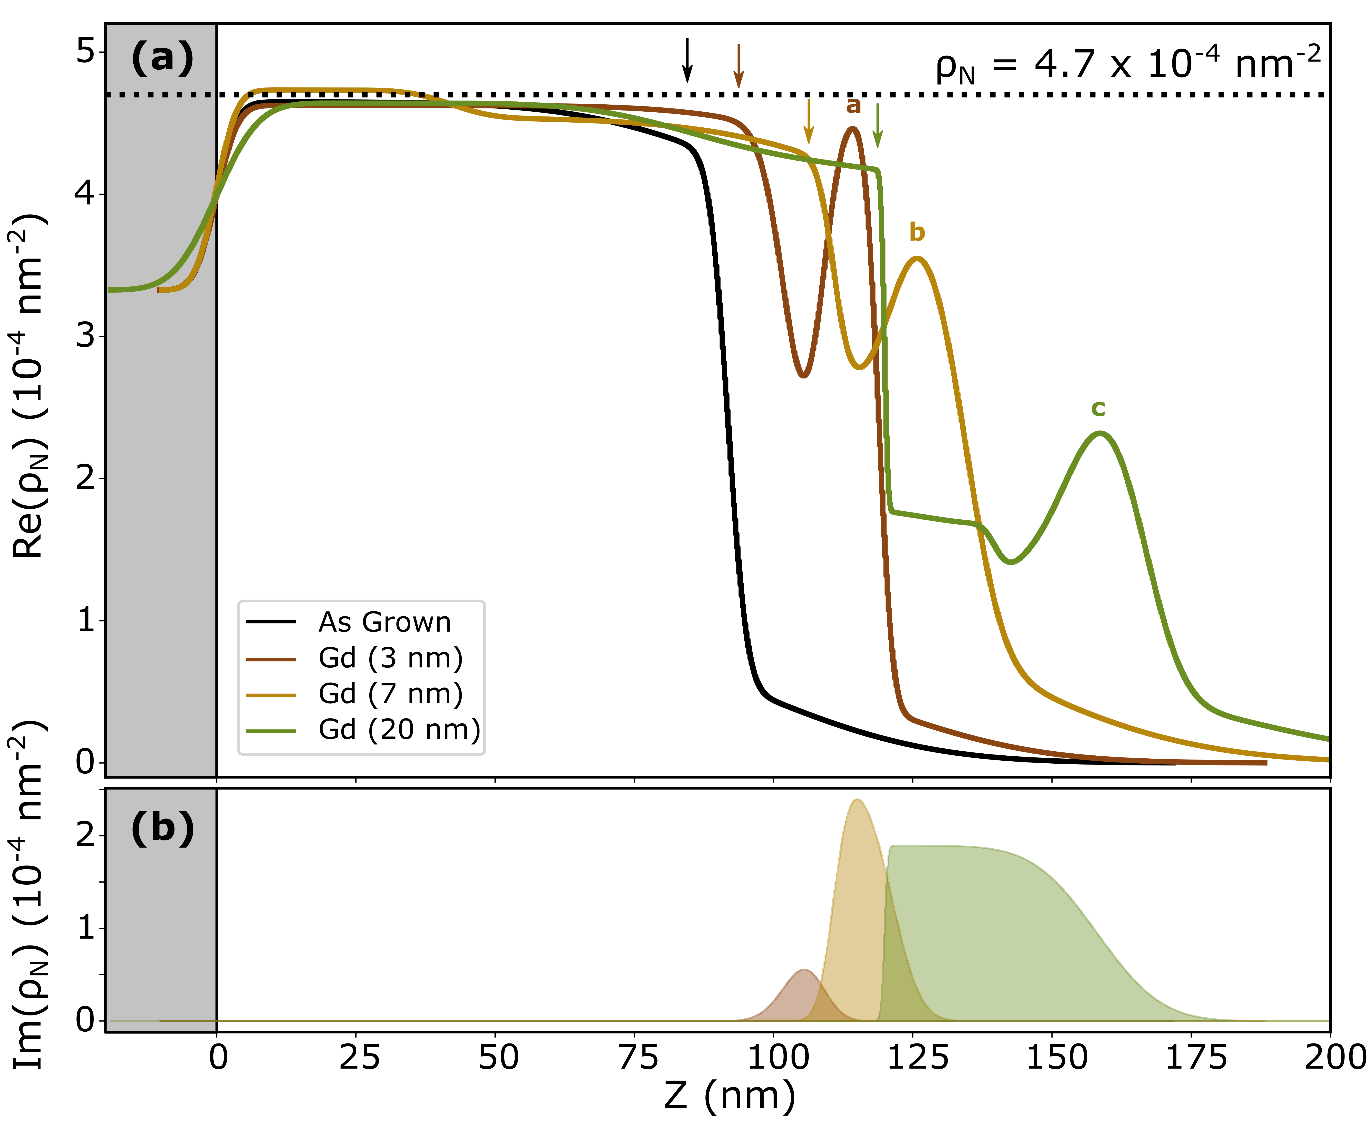

**Figure 2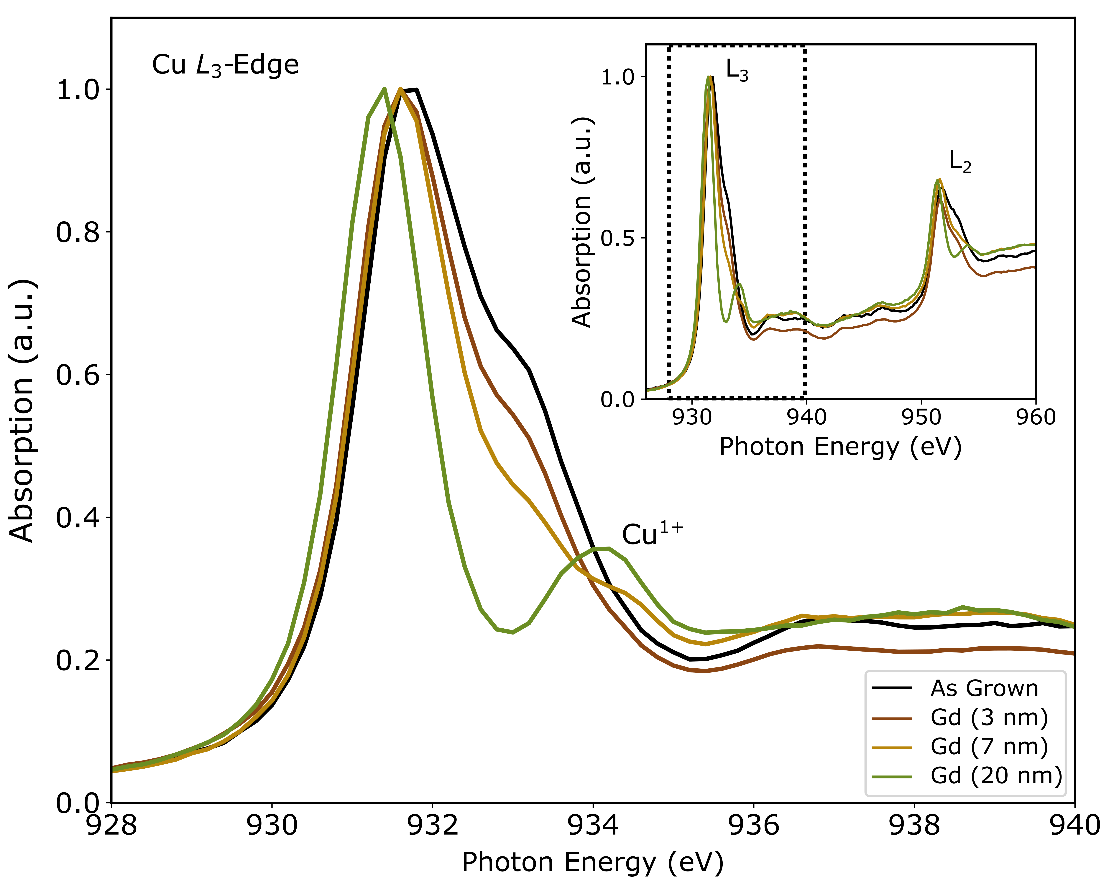Figure 4**

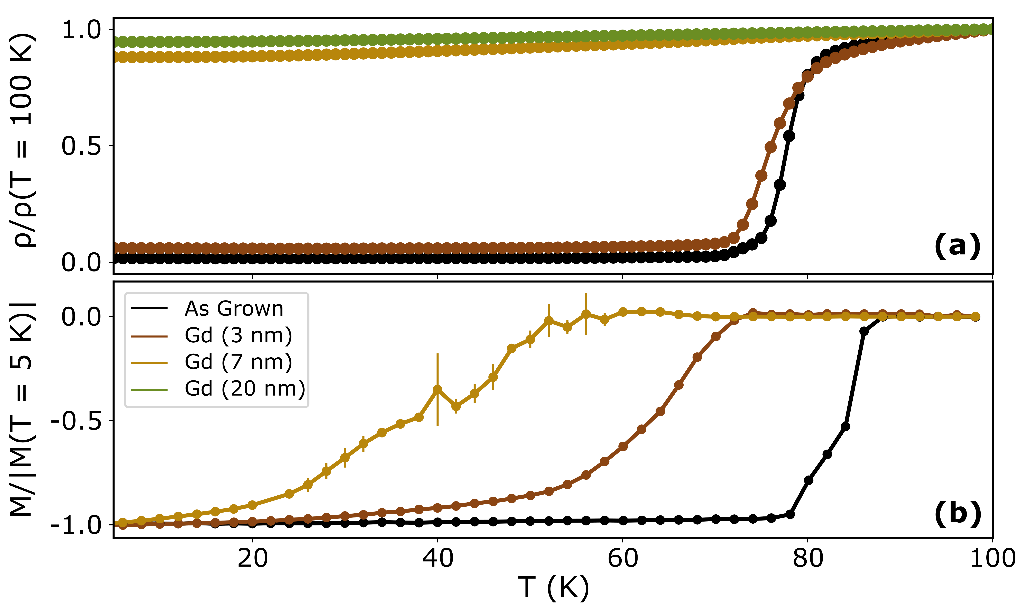

**Figure 5**